**Stock Synthesis Interface (SSI) User Guide - Version 3.30** (Beta)

The Stock Synthesis Interface (SSI) is a graphical interface for creating and running existing Stock Synthesis (SS) models. The SSI will let the user view and analyze data files for Stock Synthesis (SS), run the ss.exe program, and check for errors. The SSI will allow users to modify settings with the following options:

* Output File Settings
* Configuration
* Fleet Data
* Population
* Forecast Data

**Getting Started with SSI:**

1. Open the SSI program.



1. 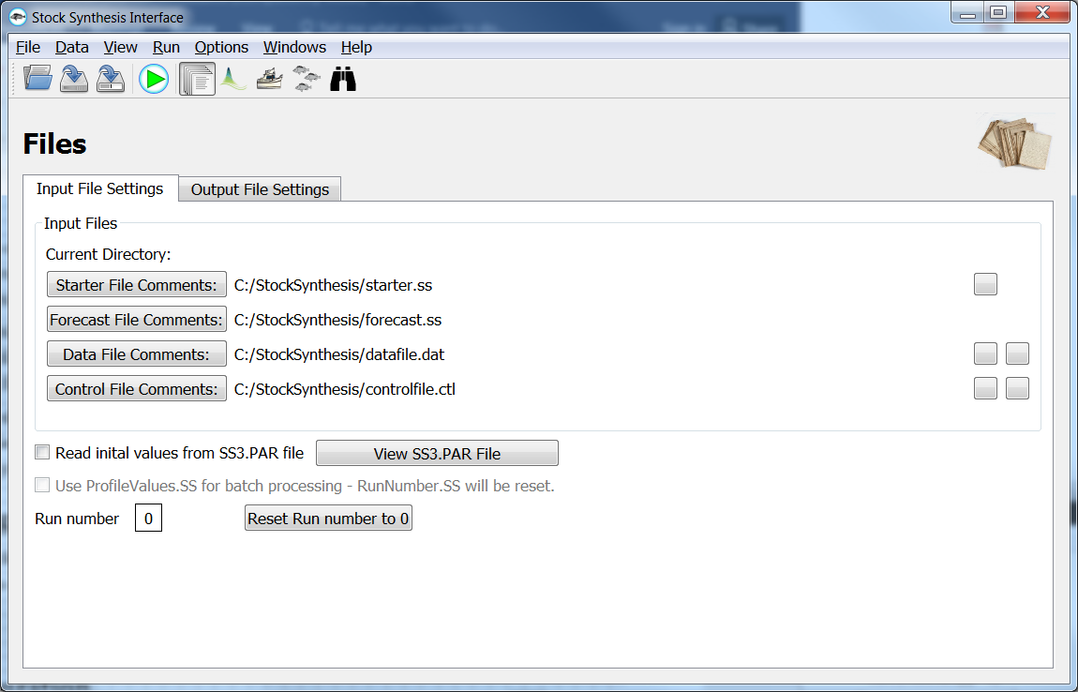After the SSI loads, it will show the Input Files Setting and the Output Files Settings menus. From these two, windows the user will load and adjust output setting for their model run. 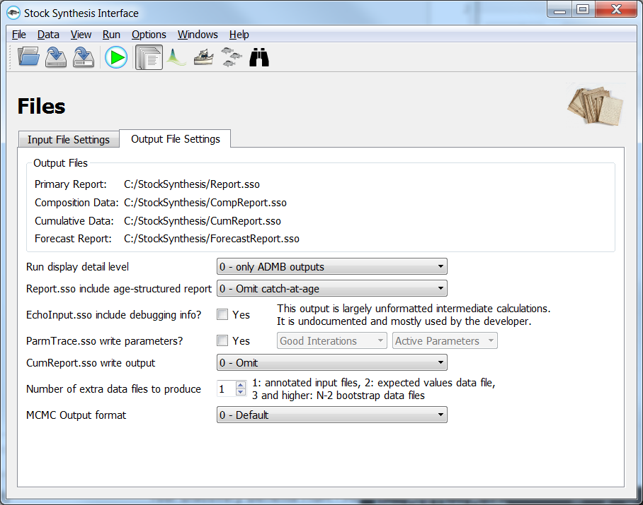
2. After the SSI has loaded go to File > Open.
3. Then select desired Starter File (starter.ss) > File Name > Open

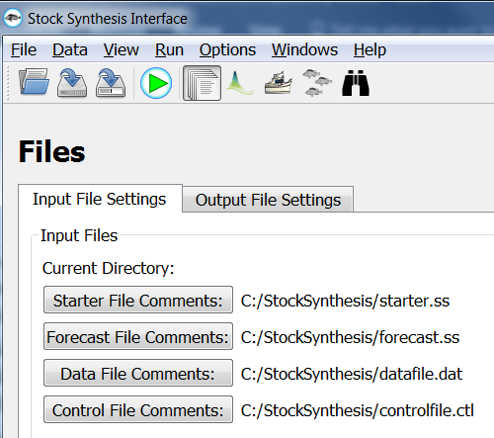

1. SSI will load the required files in the Files > Input Files Settings tab.
2. During the model set up go to the Output File Settings tab and modify options accordingly. See **Output File Settings.**
3. Click on the **green run arrow** button to bring up the Running Stock Synthesis window.

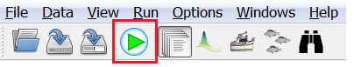

1. Press the **green arrow run** button in the Running Stock Synthesis window and the model will run.

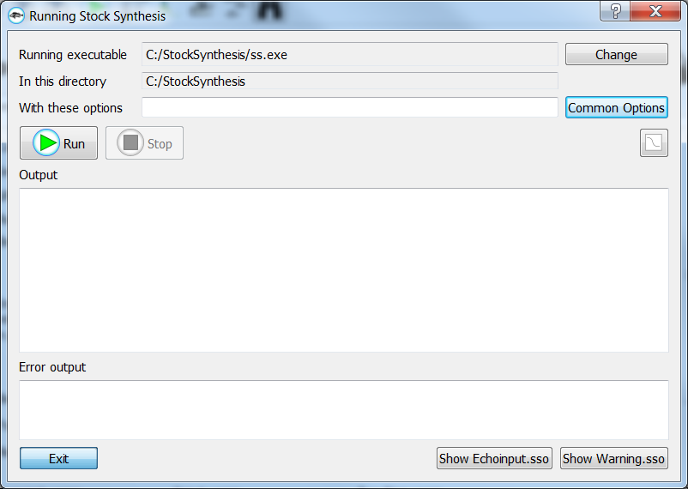

1. Once the model finishes running the run data will show in the Output and Error output windows. For further information press the **Show Echoinput.sso** and **Show Warnings.sso** buttons.

**Output File Settings:**



The Output File Settings controls what quantities are included in the Report file and whether additional diagnostic files should be written. The Output File Settings can be changed with the following options:

* **Run display detail level:** 0 - only ADMB outputs, 1 - one brief display line for each iteration, and 2 - fuller display for each iteration.
* **Report.sso include age-structured report? :** 0 - Omit catch-at-age, 1 - Complete output, and 2 - Reduced output for data-limited models.
* **ParmTrace.sso write parameters? :** Good Iterations / Every Iteration. Active Parameters / All Parameters.
* **CumReport.sso write output:** 0 – Omit, 1 - Brief Report, and 2 - Full Report.
* **MCMC Output format:** 0 – Default, 1 - Likelihood components with lambda values, and 2 - Expanded output.

**Useful Menu Options:**

**File:**

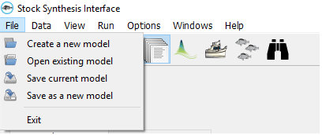

**Run:**

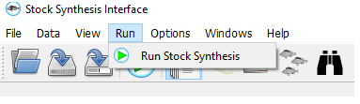

**Options:**

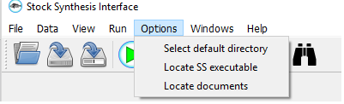

**Windows:**

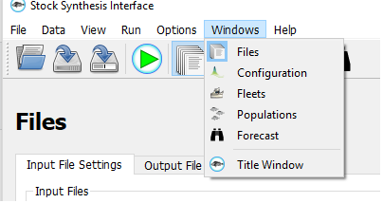

**Configuration Menu:**

**Dimensions:**  The Dimensions tab is used to specify the year range, number of sexes, seasons, areas, fishing and survey fleets to be modeled. Please see the SS User Manual– “Model Dimensions” Section 9.4.

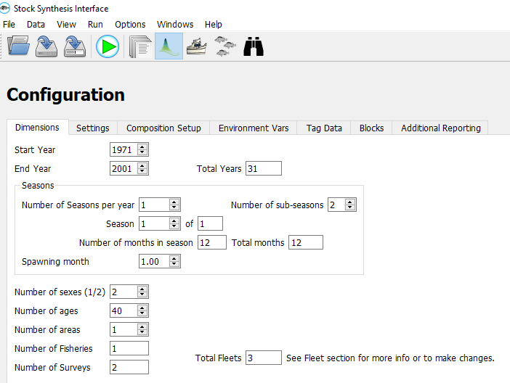

**Settings:** The Settings tab is used to specify adjustments to starting parameters, summary calculations, and model convergence. Please see the SS User Manual, “Starter File Syntax”, Section 5.

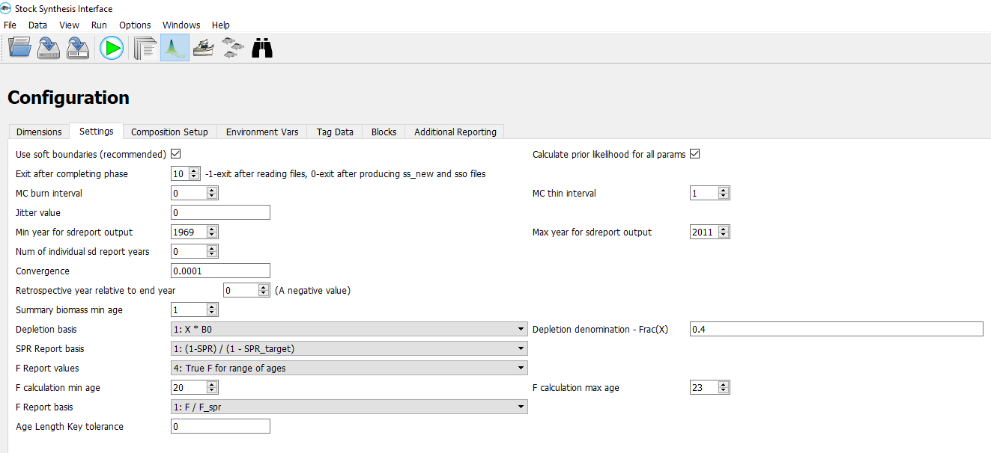

**Composition Setup:** The Composition Setup tab specifies the length bin and age bin structure to model the population and the bin structure for the input composition data. Please see the SS User Manual, “Population Length Bins”, Section 9.11.

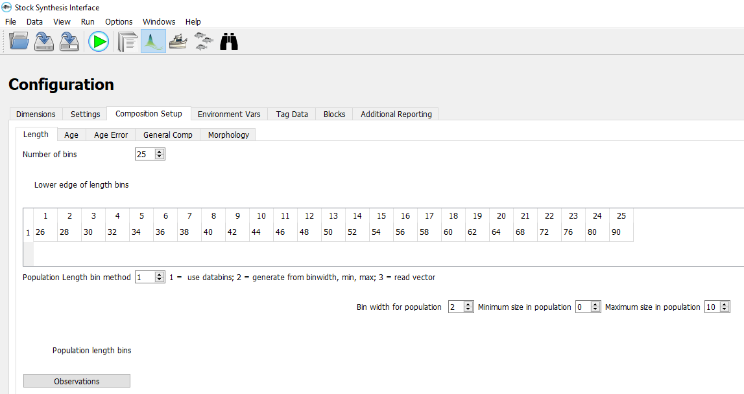

**Environment Vars:** Stock Synthesis (SS) accepts input of time series of environmental data. Parameters can be made to be time-varying by making them a function of one of these environmental time series. Please see the SS User Manual, “Environmental Data”, Section 9.17.

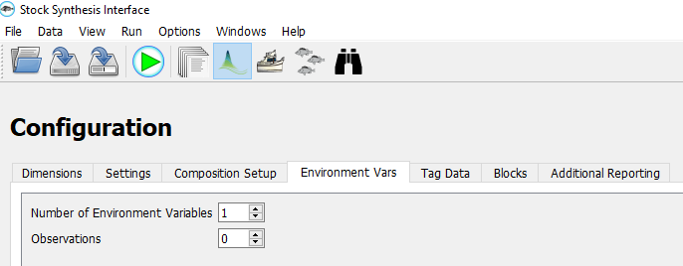

**Tag Data:** Each released tag group is characterized by an area, time, sex and age at release. Each recapture event is characterized by a time and fleet. Please see the SS User Manual, “Tag-Recapture Data”, Section 9.19.

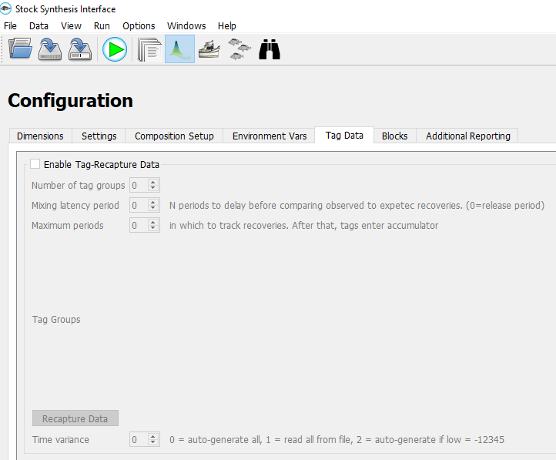

**Blocks:** The number of block patterns can be referred to in the parameter sections to create a separate parameter value for each block. Please see the SS User Manual, “Blocks”, Section 10.3.3.

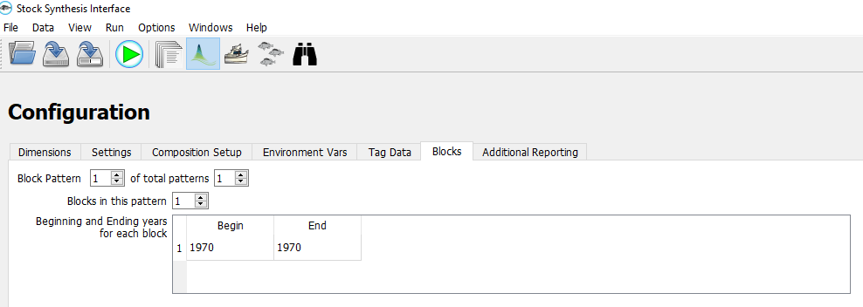

**Additional Reporting:** Additional Reporting includes: Len/Age, Year, N Selectivity, Growth Pattern, N growth bins, Area, Year, and number-at-age bins.Please see theSS User Manual, “Controls for Variance of Derived Quantities”, Section 10.12.

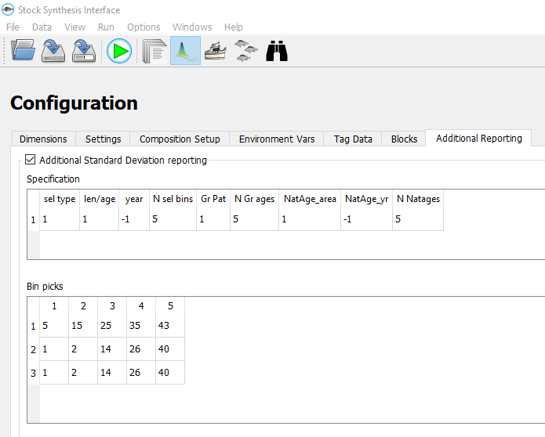

**Fleet Data Menu:**

**Basic Data:** Define and input composition data type for each fleet with data. List of the fishing fleet and survey names assigned in the data file. Please see the SS User Manual, “Forecast and Reference Points”, Section 12.8.

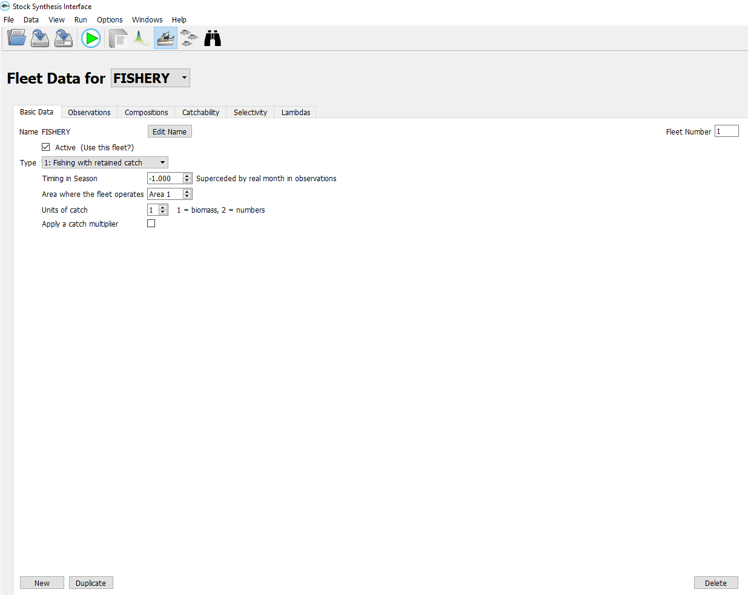

**Observations:** Timing of observations now is input as a year, month and where the month is real. A season is calculated at a runtime from the input month and the input season durations. Please see the SS User Manual, “Benchmark Calculations", Section 8.1.

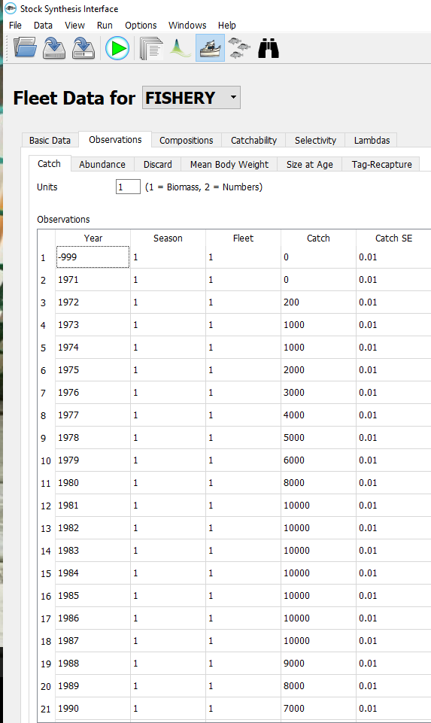

**Compositions:** Population Length Bins define the granularity of the age-length key and the coarseness of the length selectivity.Please see the SS User Manual, “Population Length Bins” sub-section “Length Composition Data Structure”, Section 9.11.

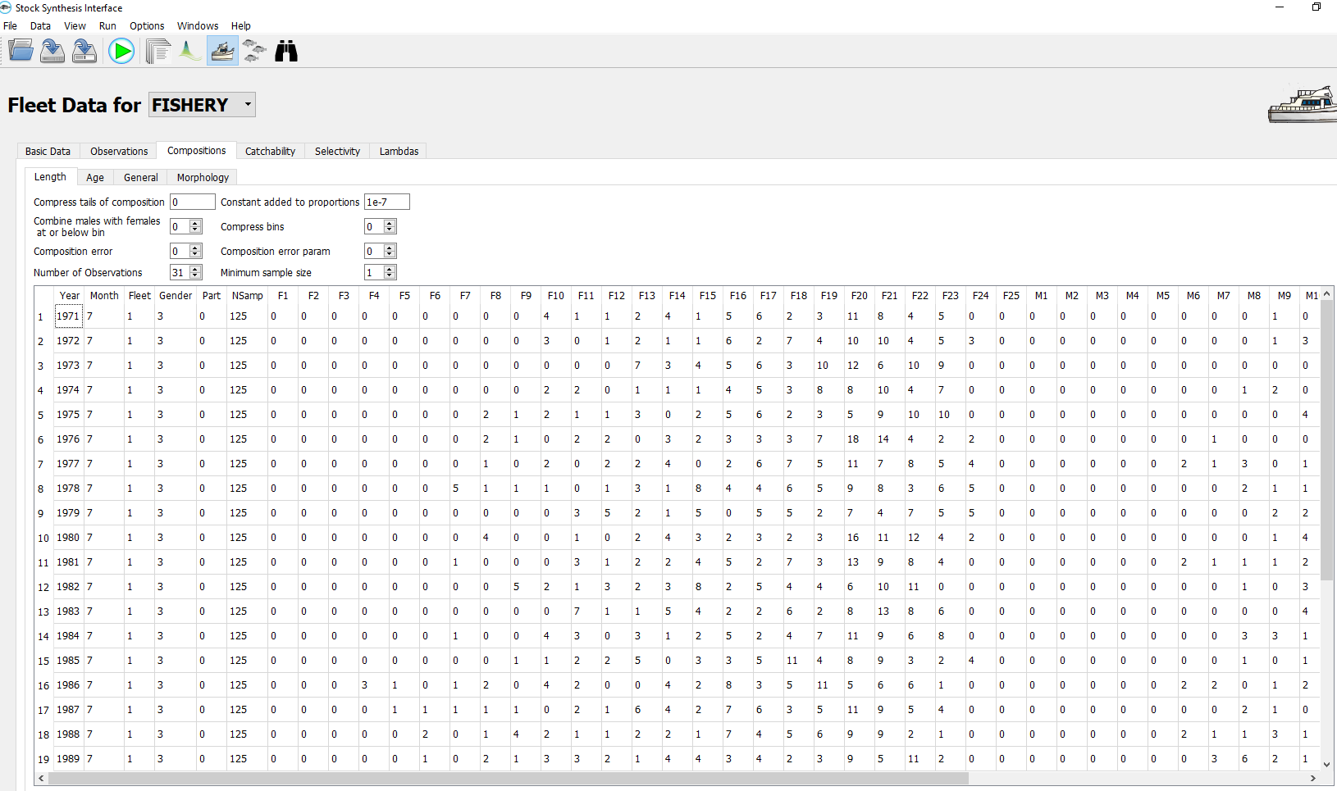

**Catchability:** Catchability is the scaling factor that relates a model quantity to the expected value for some type of data (index). Please see the SS User Manual, “Catchability”, Section 10.7.

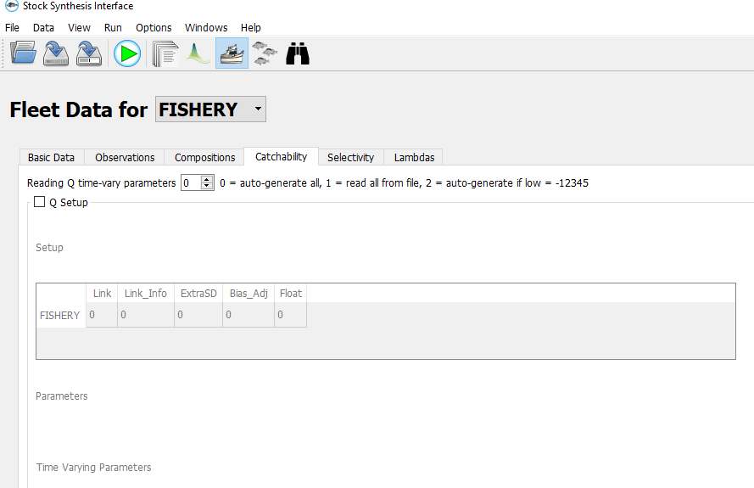

**Selectivity:** For each fleet and survey, read a definition line for size selectivity and retention. The four values read from each line are:Pattern, Discard, Male, and Special.Please see the SS User Manual, “Selectivity and Discard”, Section 10.8.

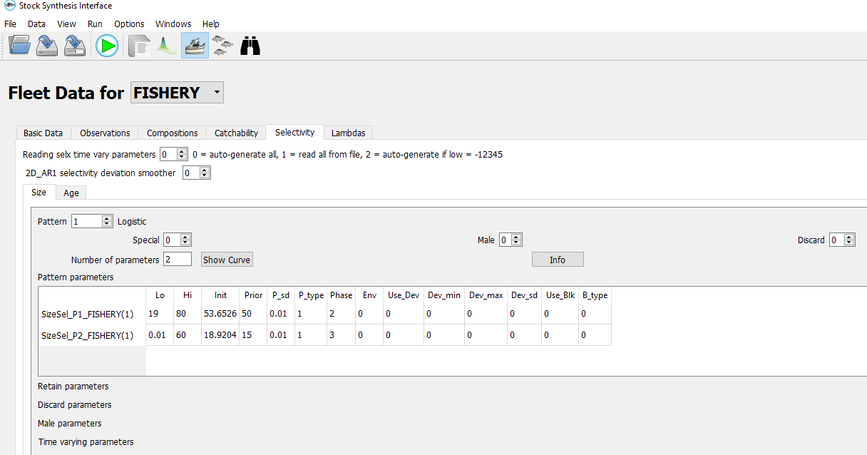

**Lambdas:** These values are multiplied by the corresponding likelihood component to calculate the overall negative log likelihood to be minimized. Please see the SS User Manual, “Lambdas” Section 10.11.

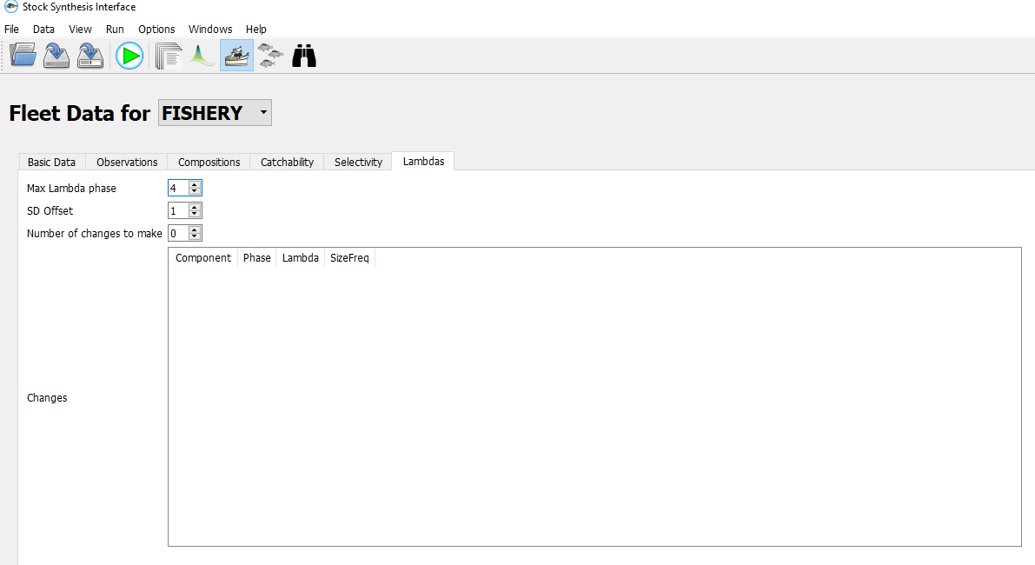

**Population Menu:**

**Growth:** Growth pattern is the number of the growth pattern to be output. Please see the SS User Manual, “Biology”, Section 10.4.

**:**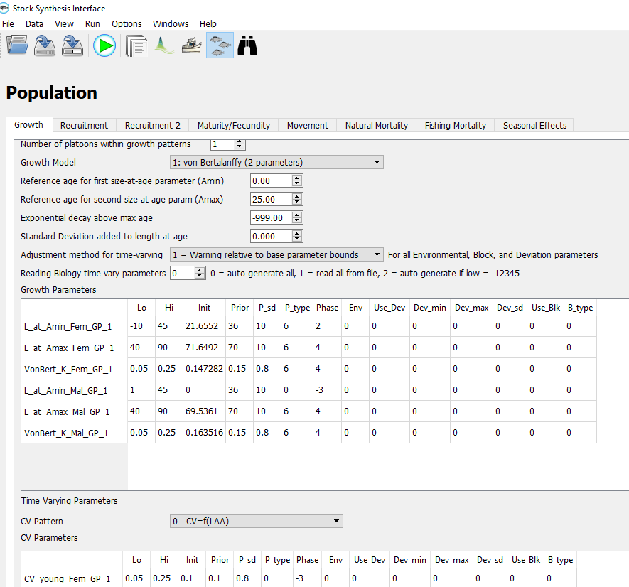

**Recruitment:** Spawner Recruitment includes these seven functions: 2=Ricker, 3=Standard Beverton-Holt, 4=ignore steepness and no bias adj., 5=Hockey Stick, 6=Beverton-Holt with flat-top, and 7=Survivorship Function. Please see the SS User Manual, “Spawner-Recruitment”, Section 10.5.

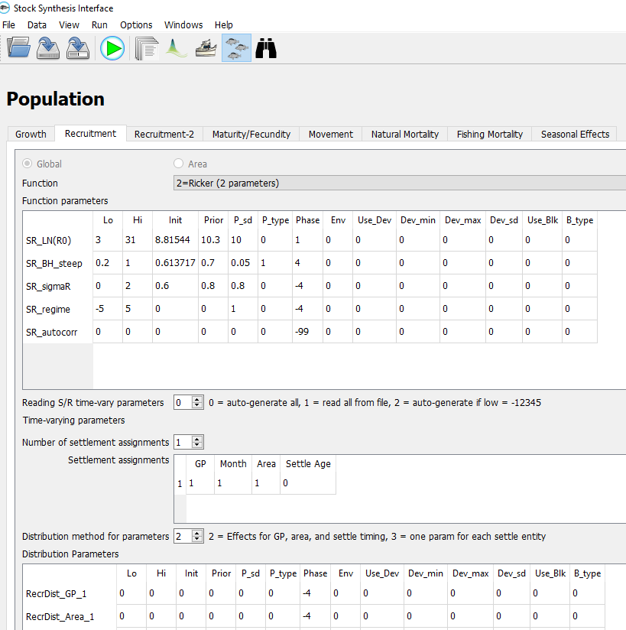

**Recruitment 2:** Forecast recruitment deviations always begin in the first year after the end of the main recruitment deviations. Recruitment in the forecast period is deterministically derived from the specified stock-recruitment relationship. Please see the SS User Manual, “Spawner-Recruitment”, Section 10.5.

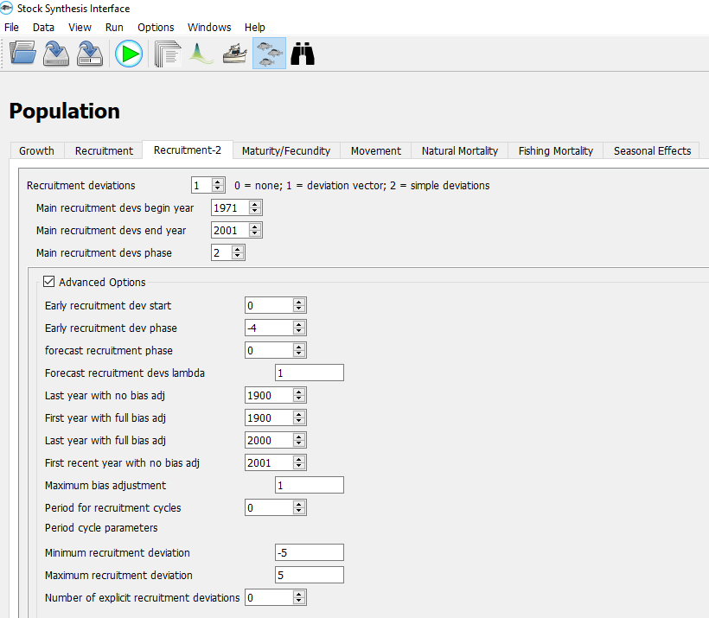

**Maturity / Fecundity:** The Maturity Options has the following options: 1: Length logistic, 2: Age logistic, 3: Read age-specific maturity for fem., 4: Read age-specific fecundity, and 5: Read empirical data from file wattage.ss. Please see the SS User Manual, "Maturity-Fecundity", Section 10.4.3.

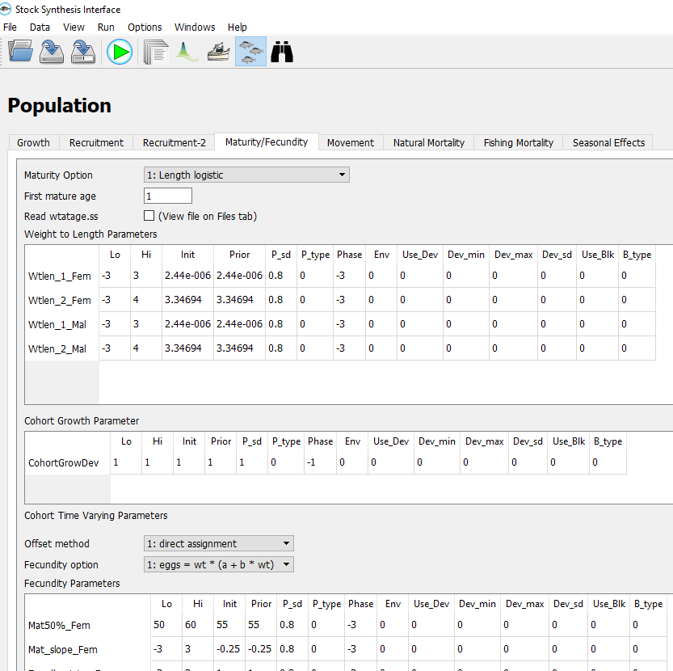

**Movement:** We define movement among the areas. This is a box transfer with no explicit adjacency of areas, so fish can move from any area to any other area in each time step. Please see the SS User Manual, "Movement", Section 10.3.2.

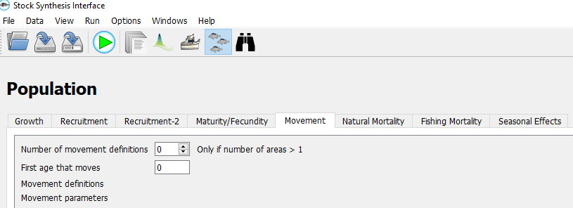

**Natural Mortality:** Natural mortality (M) has some options that are referenced to integer age, and some to real age since settlement. Please see the SS User Manual, "Natural Mortality", Section 10.4.1.

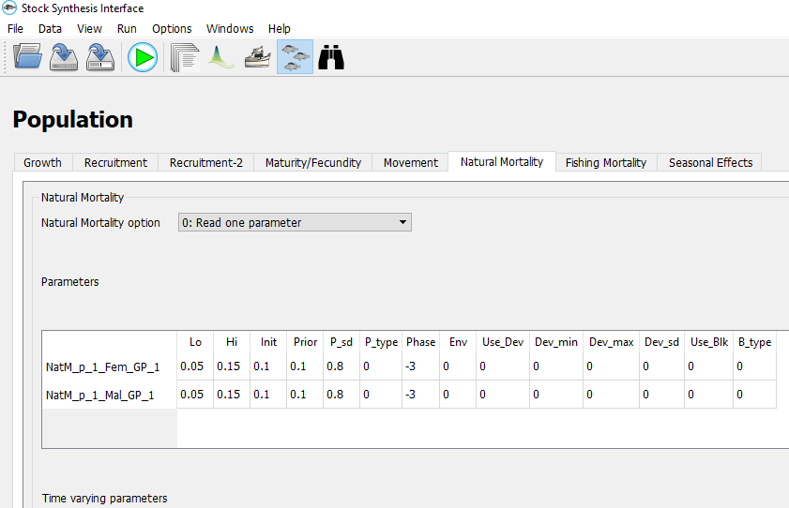

**Fishing Mortality:** The Fish Mortality has three options which include: 1= Pope’s, 2= Continuous F as parameters, and 3 = Hybrid. Please see the SS User Manual, "Fishing Mortality Method", Section 10.6.

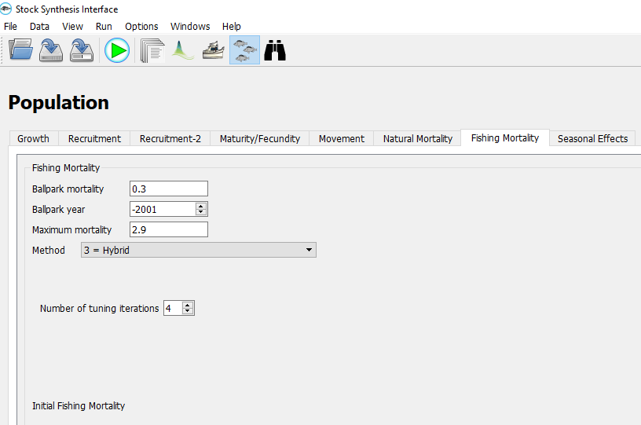

**Seasonal Effects:** Seasonal effects are available for weight-length parameters and for the growth K. Please see the SS User Manual, "Seasonal Biology Parameters", Section 10.4.10.

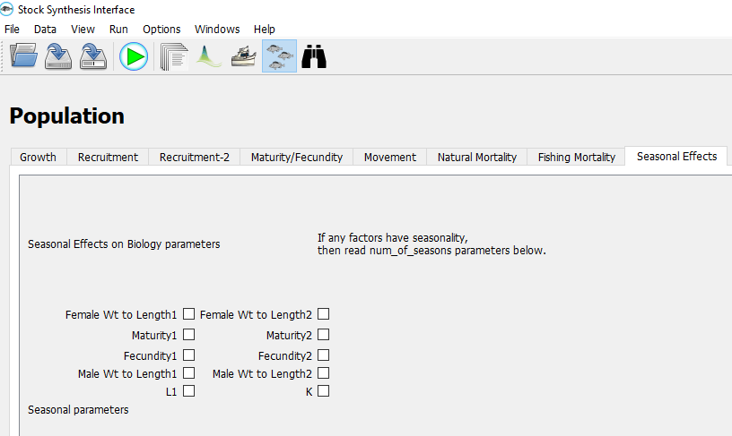

**Forecast Data Menu:**

**Specification:** Benchmark calculations are designed to calculate an equilibrium fishing rate intended to serve as a proxy for the fishing rate that would provide maximum sustainable yield (MSY). Please see the SS User Manual,"Benchmark Calculations” Section 8.1 and “MSY and other Benchmark Items” Section 12.4.6.

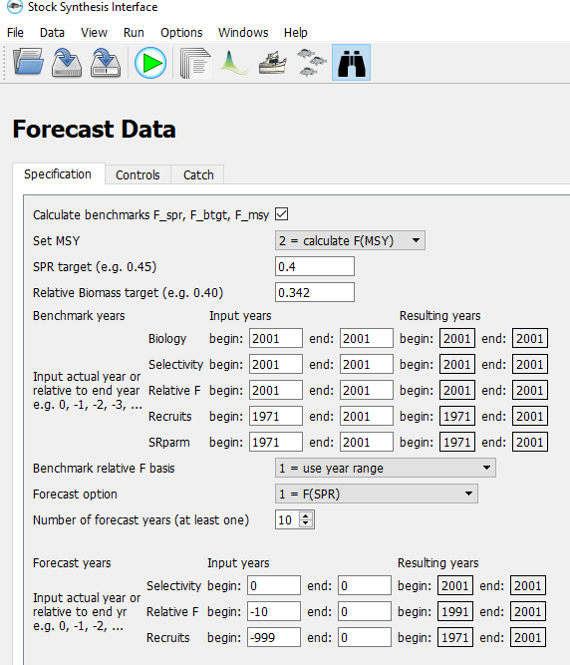

**Controls:** Forecast Selectivity Option determines the selectivity used in the forecast years. Please see the SS User Manual, "Forecast File Syntax”, Section 8.

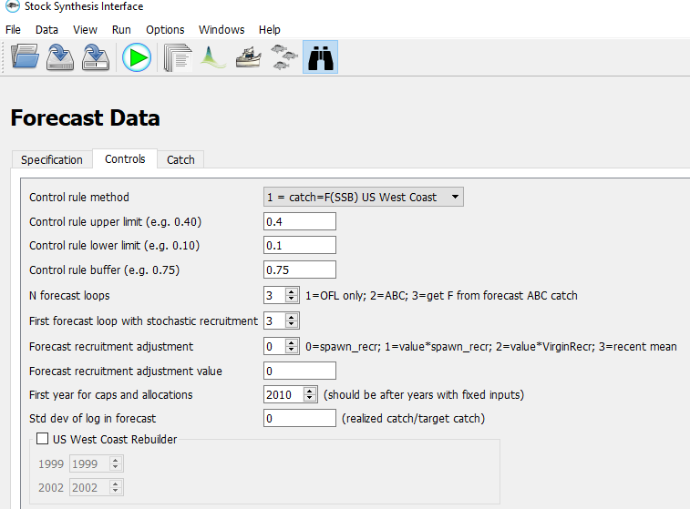

**Catch:** Catch can be in terms of biomass or numbers for each fleet. Please see the SS User Manual, "Forecast File Syntax”, Section 8.

